- What is Git and GitHub?
Git: Git is a version control system used to track changes in code and manage different versions of files. It helps developers work together and keep history of their work.
GitHub: GitHub is a cloud platform where you can store and share Git repositories online. It helps teams collaborate, review code, and manage projects easily.
Centralized Version Control (CVCS):
All code is stored in one central server, and users connect to it to work on files.
Example: Subversion (SVN, GitLab, bitbucket)
Distributed Version Control (DVCS):
Each user has a complete copy of the repository on their own system, so they can work offline.
Example: Git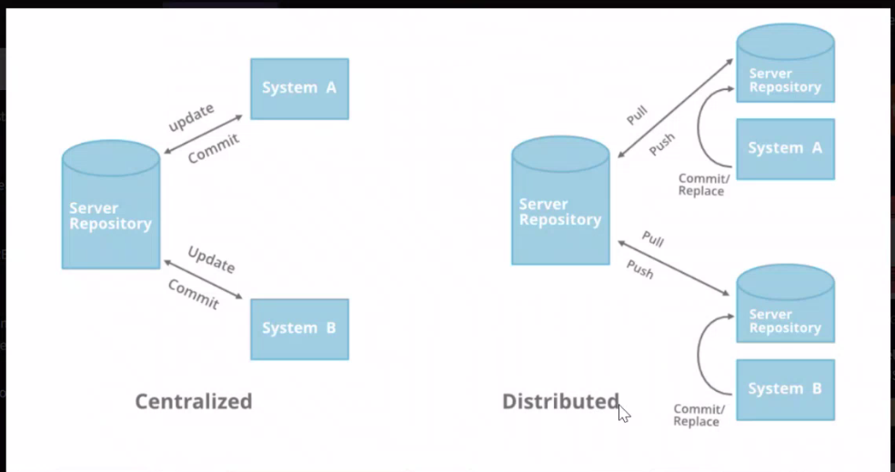
To check version using git --version
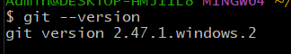
- Create file and check current directory
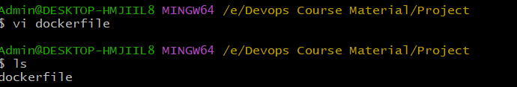
- Check status?
- Check hidden files
- How to initialized git directory
Create .git directory in E:/Devops Course Material/Project/ directory (where your right click and open Git Bash there.) now It show Main after path.
- By default created some directory in .git folder. Using ls -a command
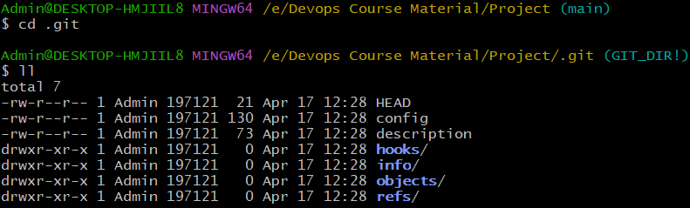
.git directory is consider some configuration file.
- After that I go one step back and hit command git status
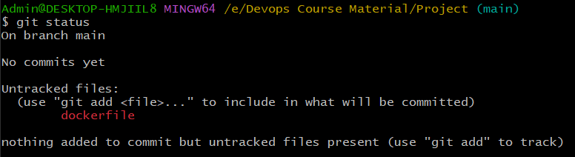
It will show untracked files in red color.
- Suppose we delete .git directory then what will happen.
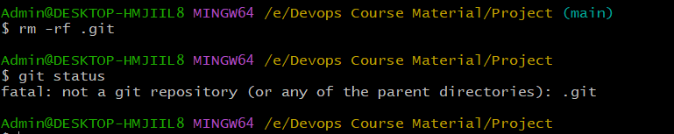
If you see in screen there is no showing main after path of the directory. Again initialized using git init command.
- To complete details of repository use git config –list command you will see complete details.
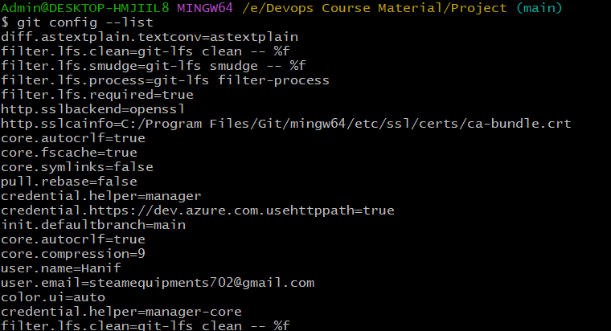
Without user.name & user.email you cant push local repository to center repository. This is one time activity only.
- To configure your user.name & user.email. use command git config –global user.name.
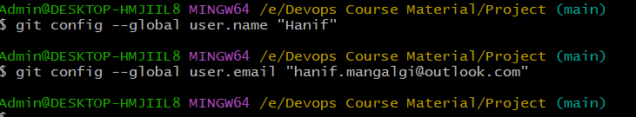
Now using config command to check user.name & user.email will change or not.
- Now push your code to untracking area to Tracking area using git add. Command.
Note Git add . means all file or you can use git add file name to particular file or multiple file.
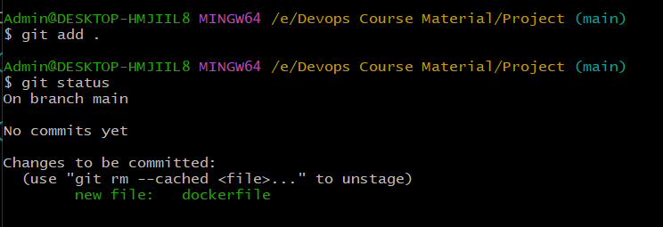
Also check after git status command it shows file is no in tracking area.
- After adding some file in tracking area then you create some new file using touch command.
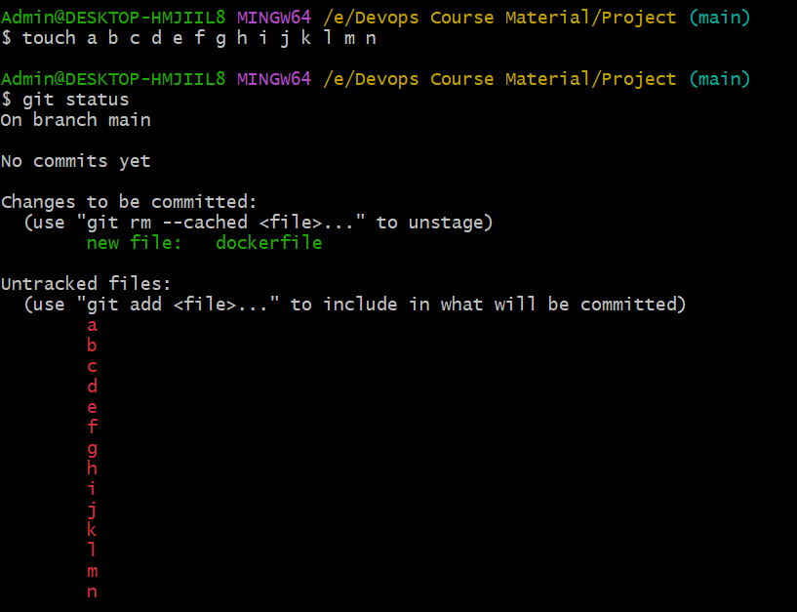
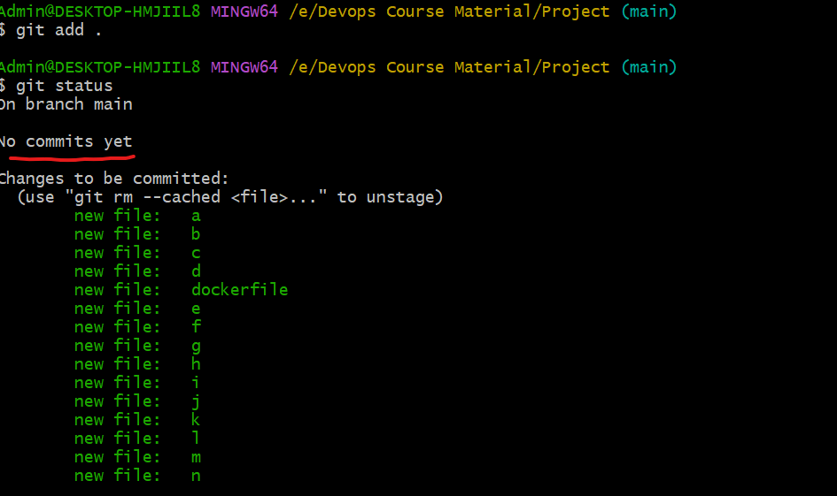
Why it show no commits yet mark red above image.
- Using git comment -m “Your message for commit” command use to commit in local repository
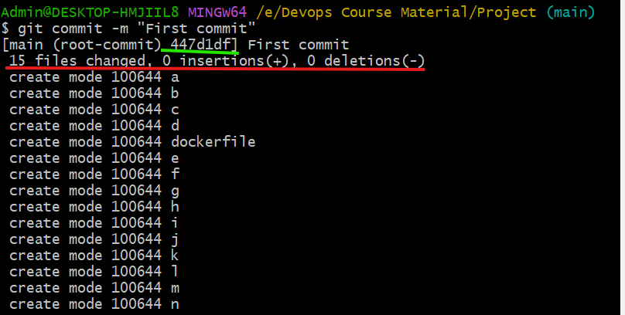
Details show in red mark place and green color show commit ID above screen
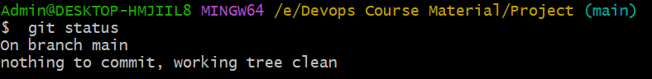
Not there is no new file in untracking & tracking area.
Note related commit id (if you have commit id then you can reverse the changes)
- How to check commit id. Using git log command
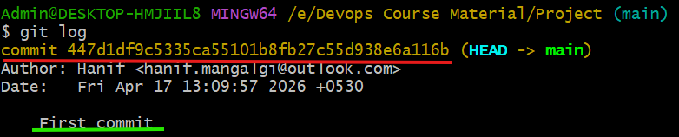
Red color line is commit id (use only 4 or 5 digit)and green color line is commit message.
Now connect to Central repository
- Create account in github.com. go to singup form
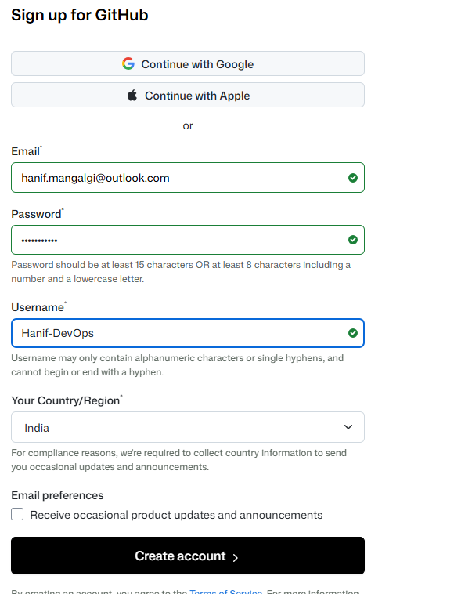

- First configure you GitHub account with local repository
- Then create repository on GitHub website. Below is step
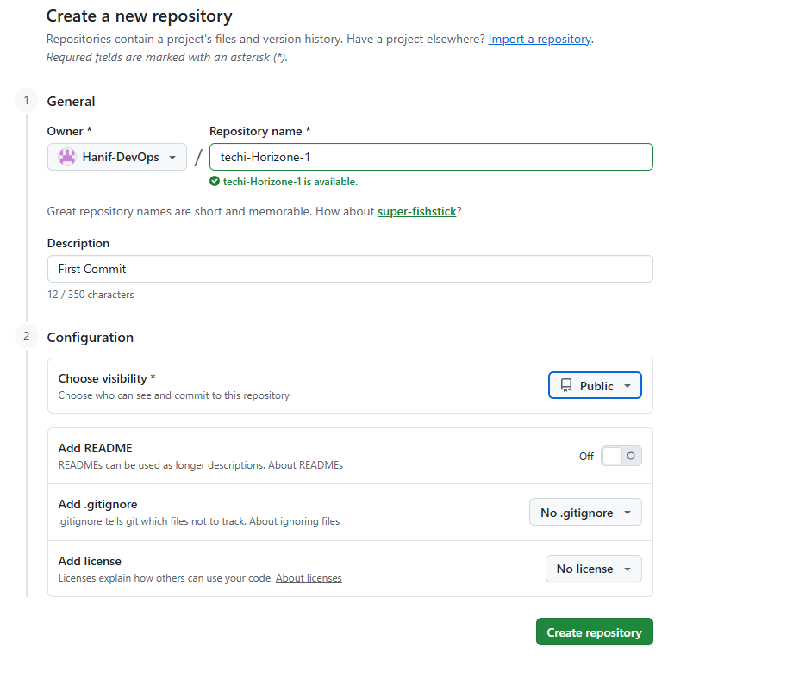
Click on create repository button show in image.
- How to check address is configured or not.
It not show nay url is configured to this git account.
- To configure your central repository to use command is git remote add origin
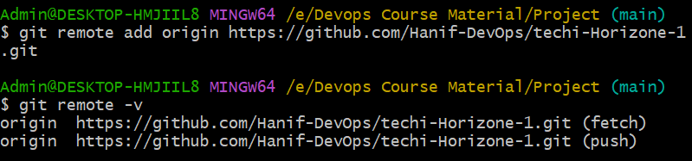
Remote repository is configured and check status also

- Now we should provide the authentication.
Generate ssh key using ssh-keygen if you ask then press Enter button 3 to 4 time.
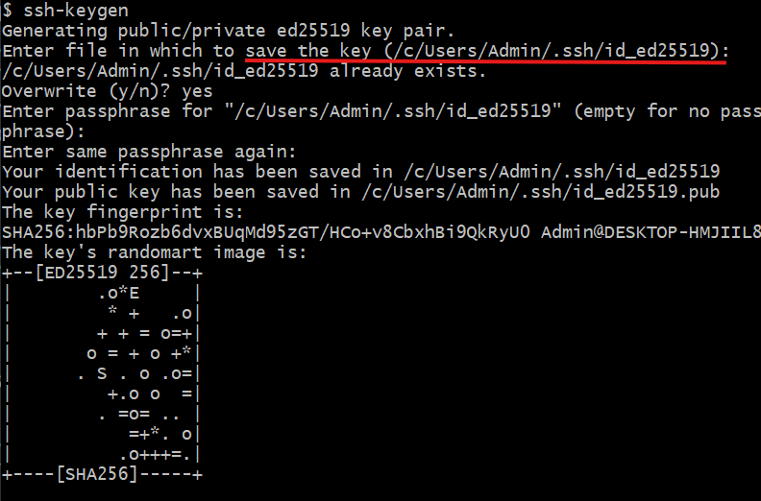
Red color line is your key(/c/Users/Admin/.ssh/id_ed25519.pub)
Now using cat (/c/Users/Admin/.ssh/id_ed25519.pub) open file and copy the key
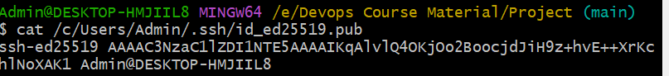
Go to GitHub account – settings -ssh and gpg keys- find SSH keys –click on new ssh key
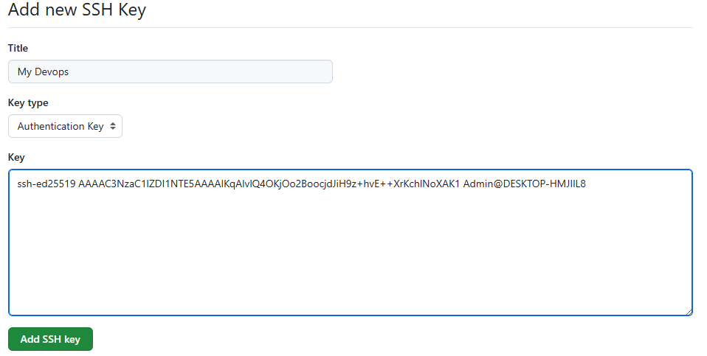
Click on add ssh key button it done.
Now you can push your data to central repository.
- Using git push command to push data to central repository. git push -u origin main(main is branch name).
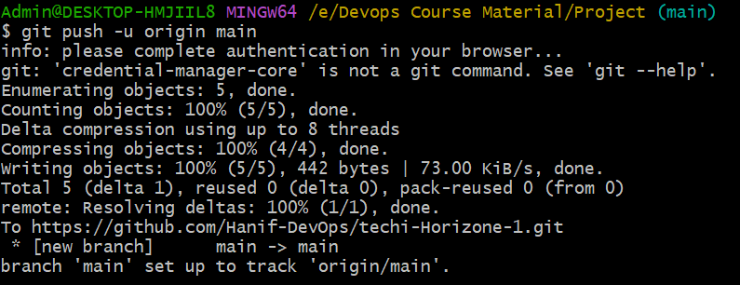
Ask you to authorize key. To log in your account. Now you see below screen in gihub account.
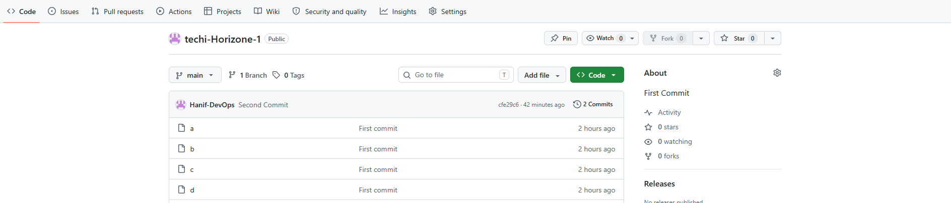
- I want to delete my dockerfile name file from local repository.

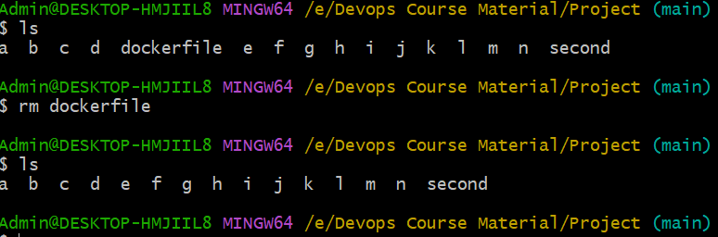
File deleted in local repo. If you check repo status you will see below screen.
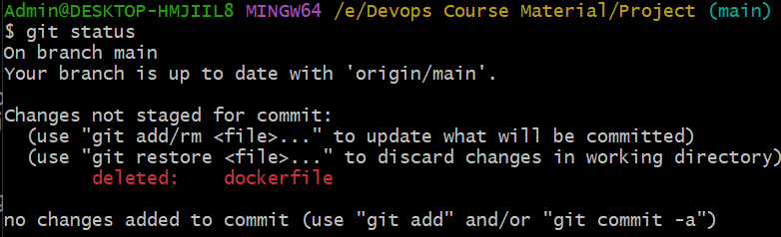now I want to commit changes using commit command.
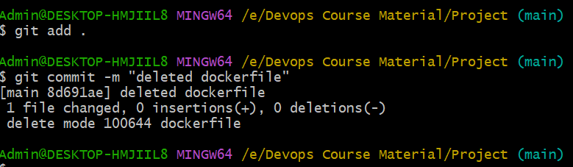
Now I want push my local repo to central repo using git push -u origin main command
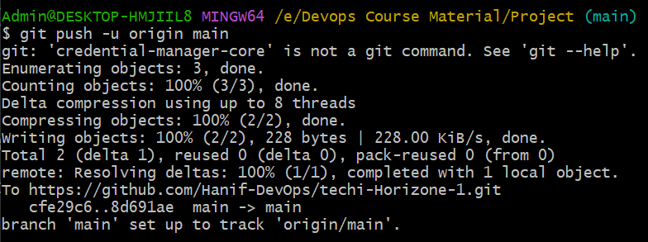
Now file is deleted from central repo.

If something is change in central repo then first you get pull from central repo and then push you data to central repo other wise it show error.
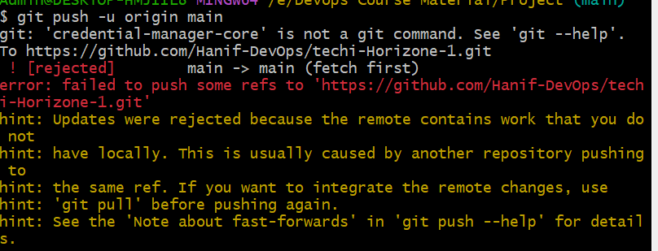
so now first you pull changes from central repo to local repo using git pull command.

- How to pull from central to local repo. After pull command it show new file added or changed in with file name. red color line shows that file.
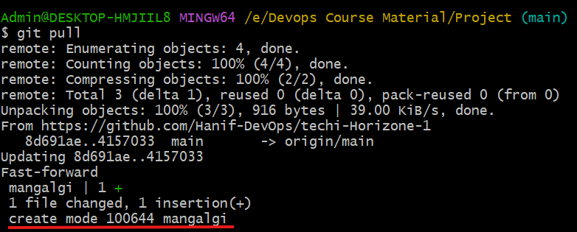
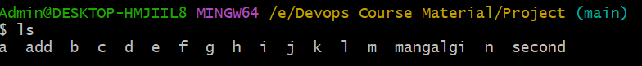
Now that file is show you. After ls command. Now you can push your changes using push command.
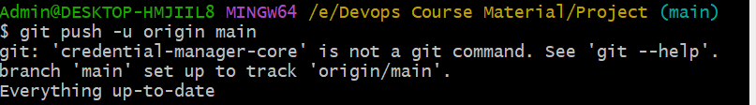

Git clone git pull git fetch command difference.

- I want to clone repository. git clone paste ss url.
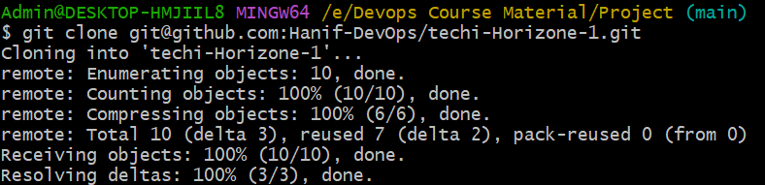
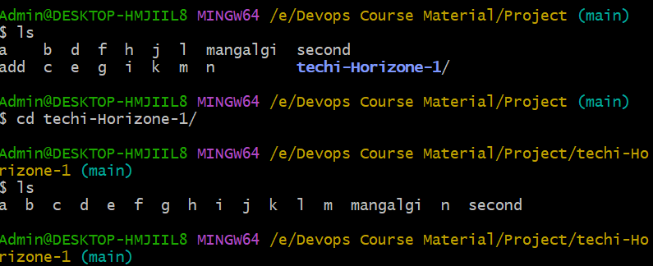
Now you see the git clone command use to download complete repo is clone. Git clone get me the complete details of repo. And git pull is get only update changes in you local machine. Git pull only work if you have any data repository (local repo) then.

- To revert commit changes. How can we revert changes.
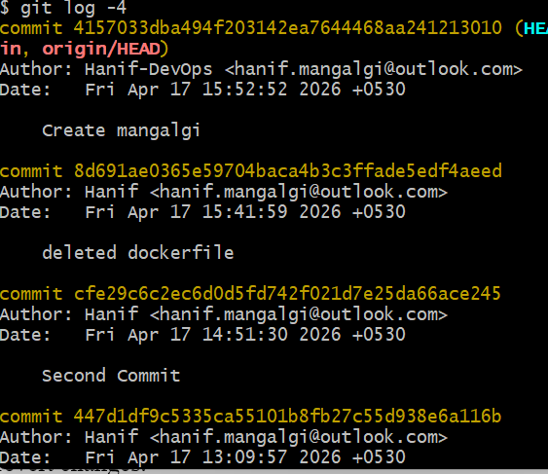
- Copy first 4 digit of any one commit id use command git revert 4 digit which is copy of commit id.
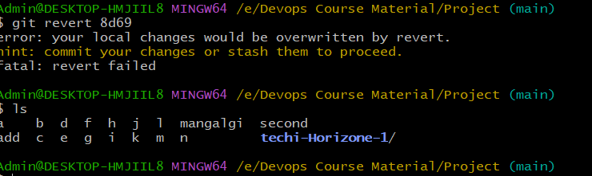
- In Central repo there is file REDME.markdwon to understand the project and all thing.

